The fine wine market in Q1 2023
- Fine wine continues to offer stability in periods of economic uncertainty and volatility.
- However, all the major Liv-ex indices are down year-to-date.
- The Champagne 50 was the worst-performing index of the Liv-ex Fine Wine 1000.
- The top-traded wines this quarter came from Champagne, Bordeaux and California.

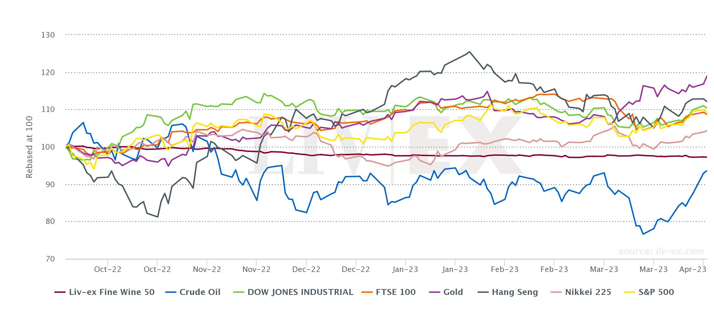
It seems that Q1 is acquiring a reputation for being a turbulent quarter. This time last year, the Russian invasion of Ukraine had exacerbated inflation concerns, while the knock-on effect of war caused oil, gas and metals to rise in price which further impacted struggling global supply chains. To add to the situation, China — a major buyer on the secondary market — endured a severe wave of Covid-19, turning its mega-cities into ghost towns.
One year on, the world is once again witnessing major turbulence but this time, it’s financial in nature. The collapse of Silicon Valley Bank sent shockwaves through markets, closely followed by the controversial UBS takeover of its rival Credit Suisse. The major markets all fell from January to March in the wake of Silicon Valley Bank’s collapse. However, since the beginning of March they have bounced back hard, with many now at all-time highs.
While the fine wine market has not experienced the same gains in Q1, it continues to offer stability in periods of economic uncertainty and volatility. However, despite modest improvements in March, all of the major Liv-ex indices are down year-to-date. While these declines aren’t quite as steep as some of the falls in the bond and equities markets, their relative stable performance masks some bigger causes for concern.
Fill in the form below to claim your complimentary copy of the report.

[form]

About Liv-ex
Liv-ex analysis is drawn from the world’s most comprehensive database of fine wine prices. The data reflects the real time activity of Liv-ex’s 620 merchant members from across the globe. Together they represent the largest pool of liquidity in the world – currently £100m of bids and offers across 16,000 wines. Independent data, direct from the market.

