**Regional market share – a continuation of the past?**

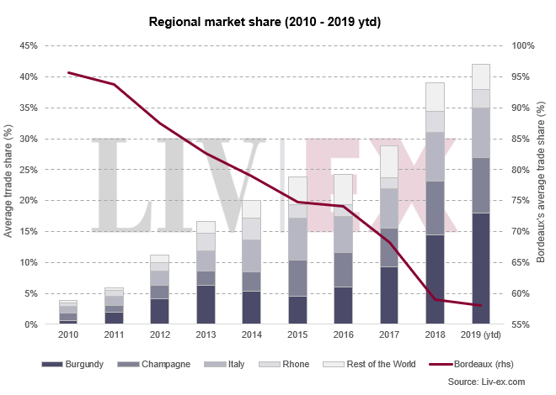

In our last [yearly update](https://www.liv-ex.com/2018/12/year-2018-regional-market-share/) on the shape of the fine wine market, we noted its continuous broadening – more wines from more regions attracting buying interest. So far, 2019 has not only sustained this trend of diversification but has also seen Burgundy’s trade share by value reach a new record.

Burgundy’s average share has risen from 14.5% in 2018 to 18.4% this year, peaking in May when the region hit a monthly high of 22.6%. This consequently affected Bordeaux’s activity, which fell to its lowest level for the year (55.3%) that month.

Still, Bordeaux’s share has seen little volatility, trading in the 55%-62% range. Prices for Bordeaux have also held steady this year, evident in the performance of the [Bordeaux 500 index](https://www.liv-ex.com/2019/07/liv-ex-1000-index-gains-0-7-july/).

Burgundy’s share, on the other hand, has been rising in the context of its declining market. The [Burgundy 150](https://www.liv-ex.com/2019/07/liv-ex-1000-index-gains-0-7-july/) has dipped 6.2% year-to-date, a possibility we discussed in our special report ‘[Burgundy: in the spotlight](https://www.liv-ex.com/2019/01/special-report-burgundy-spotlight/)’. More Burgundy stock has also become available, a sign perhaps that interest has started to shift towards other regions.

Within the fine wine world, Champagne has seen the most volatile activity, disguised under the surface of a flat average yearly share. The region accounted for only 4% of the total trade by value in April but hit an all-time monthly record of 19.3% in June.

Tune back in December for the final numbers for 2019.