**Gruaud Larose 2018 released**

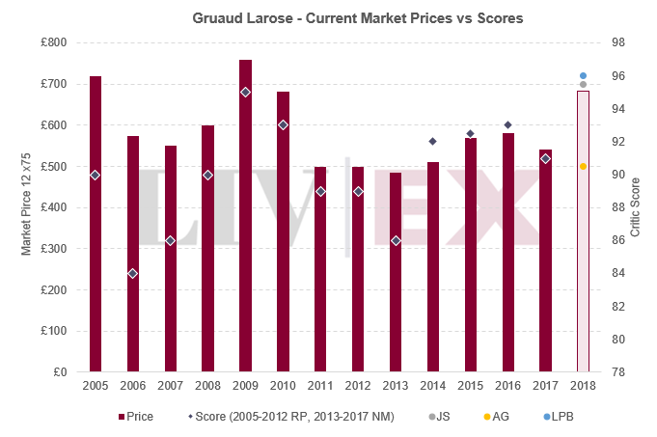

Gruaud Larose 2018 has just been released at €55.20 per bottle ex-negociant, up 6.6% on the [2017 opening price](https://www.liv-ex.com/2018/06/canon-2017-released/) of €51.80. It is being offered by the international trade at £684 per 12×75, up 12% on the 2017’s release of £615 per case.

Lisa Perrotti-Brown MW ([The Wine Advocate](https://www.robertparker.com/)) called the wine a “very exotic Gruaud” and awarded it 95-97 points. [James Suckling](https://www.jamessuckling.com/), who gave it 95-96 points, said it “is really generous and rolls off the tongue with ripe and velvety tannins and a fresh undertone”.

Antonio Galloni ([Vinous](https://www.vinous.com/)) scored today’s release a lower barrel range of 89-92 points and described it as “inky, jammy and full-bodied”.

For Chris Kissack ([The Wine Doctor](https://www.thewinedoctor.com/), 94-96), “this is a rather strong showing for Gruaud-Larose”.

At this price level, today’s release stands above most vintages available in the market. The 2016 looks particularly attractive as it is 15.3% cheaper and boasts 93 points from Neal Martin. Alternatively, those looking for older vintages might want to consider the 2010 (RP 93), which is also available at a small discount.